**IOT BASED FARMERS HELPER**

**by**

**Naveen Gupta 19BCE1791**

**Mahavir lunkad 19BCE1774**

**P Sanjana Reddy 19BCE1581**

A project report submitted to

**Dr. Maheswari R**

**SCHOOL OF COMPUTER SCIENCE AND ENGINEERING**

in partial fulfillment of the requirements for the course of

**CSE3501 – IoT Fundamentals**

in

**B. Tech. COMPUTER SCIENCE AND ENGINEERING (CPS)**



**Vandalur – Kelambakkam Road**

**Chennai – 600127**

**DECEMBER 2021**

**ABSTRACT**

This Project presents a smart system to predict the irrigation requirements of a field utilizing the detecting of ground boundaries like soil moisture, soil temperature, and ecological conditions alongside the climate figure information from the Internet. The detecting nodes, engaged with the ground and ecological detecting, consider soil moisture, soil temperature, air temperature, Ultraviolet (UV) light radiation, and relative humidity of the yield field.This also serves the purpose of saving the crops from wild animals with the help of proximity sensors and alarms.

The application explicit sensors' information securing and intelligent processing, are spanning the holes between the cyber and physical worlds. IOT based smart irrigation management systems can help in accomplishing ideal water-asset use in the accuracy cultivating scene. India being a developing country, agriculture is still the primary occupation of the majority of people.Presently the organic market of rural items has not been controlled as expected in light of physically estimating the ecological boundaries by the farmers. Hence, adoption of technology based farming is necessary to increase the revenue.Indeed, even the climatic changes and precipitation has been unpredictable in the course of recent many years. Absence of precipitation and over the top precipitation both are hazardous to the development. The connection examination between the yield factual data and rural climate data improves the capacity of the ranchers to dissect the current condition and foresee the future gathering. In this paper, the sensor innovation and remote organization in joining with IoT has been considered and evaluated dependent on the real rural framework. Here a circulated remote organization of sensors is utilized to gather the ongoing information of the different natural boundaries. The system involves image processing techniques to identify the leaf diseases. This project also shows the data analysis in R programming of mean temperature,mean pressure,humidity and wind speed.Collected data of 20 years and with this collected data we have calculated the mean temperature,mean pressure,humidity and wind speed and plotted the graph of previous data through this analysis we have also predicted the future data to know the type of crop grown and the type of weather condition at a particular time. Two types of algorithms are used in R programming: simple moving average and exponential smoothing algorithm.

Node red flow is used and programmed to show the current weather conditions such as max,min temp , wind direction , deg,gust,visibility,sea level,ground level,pressure,cloud number.

**INTRODUCTION**

The identification of the techniques of smart farming that can give a boost to the deteriorating traditional agricultural sector. Use of smart techniques like Precision farming, efficient water management, Soil moisture and humidity monitoring are sure-shot methods to increase yield per acre of land. Accuracy Agriculture stays away from the inappropriate and overabundant use of pesticides and composts and empowers the rancher to utilize land as indicated by its quality and nature. Accuracy Farming is a possible salvager when the water tables in India are diminishing at a speedy rate due to amazing revenue by the plant and present day regions.Farmers still procrastinate or stubborn to traditional practices and delay in implementation may further decrease the GDP in India. Recently skill acquired migrants all over India who had returned to their natives during the Pandemic Covid-19 had chosen farming as their profession and are not interested in going back. These migrants can now move closure to smart agriculture systems as it takes less time than traditional farmers to convince them to adopt the implementation of Smart agriculture system.

This Project presents a smart system to predict the irrigation requirements of a field using the sensing of ground parameters like soil moisture, soil temperature, and environmental conditions along with the weather forecast data from the Internet. The detecting nodes, engaged with the ground and natural detecting, consider soil moisture, soil temperature, air temperature, Ultraviolet (UV) light radiation, and relative humidity of the harvest field.We also learned how these different sensors, namely Humidity, Temperature and Sunlight, work and how we can combine them to form an invention that will end up ultimately helping our society.

Through R programming, prediction of future weather conditions helps farmers to predict what crops can be grown in a particular season with the data to mean temp , mean pressure, wind speed, humidity.

Smart farming is a hi tech and powerful process for doing agriculture and developing food in a manageable manner. It is a use of executing associated gadgets and imaginative advances together into farming. smart Farming significantly relies upon IoT subsequently disposing of the need of actual work of ranchers and cultivators and consequently expanding the usefulness in each conceivable way.With the recent agricultural trends dependent on agriculture, the Internet of Things has brought huge benefits like efficient use of water, optimization of inputs and many more. What had the effect were the gigantic advantages and which has turned into a changed horticulture in the new days.

IoT based Smart Farming further fosters the entire Agriculture structure by checking the field consistently. With the assistance of sensors and interconnectivity, the Internet of Things in Agriculture has saved the lives of the ranchers as well as decreased the excessive utilization of assets like Water and Electricity.

**LITERATURE SURVEY**

Irrigation is most important for high yield of the farm. Today, by utilizing WSN innovation it is feasible to screen and control the natural conditions such as soil moisture, temperature, wind speed, wind pressure, salinity, turbidity, humidity etc for irrigation.

In the current time, the farmers use water system strategies through manual control, in which the ranchers flood the land at normal spans. This interaction appears to devour more water and results in water wastage.Moreover, in dry areas where there is inadequate rainfall, irrigation becomes difficult. Hence, we learn from the research of

**[1] S. Darshna et al. 2015** the requirement of an automatic system that will precisely monitor and control the water requirements in the field. Installing a Smart irrigation system saves time and ensures judicious usage of water. Moreover, this architecture uses a microcontroller which promises an increase in system life by reducing power consumption. With this work we understand how to optimize water usage during irrigation but we also need a system to monitor moisture levels in the soil and the project done by

**[2] Shristi Rawal, 2017** provided an opportunity to study the existing systems, along with their features and drawbacks. The proposed framework can be utilized to turn on/off the water sprinkler as per soil dampness levels thereby automating the process of irrigation which is one of the most time-consuming activities in farming. Learning from the drawbacks of the study done by Darshna S. the Project ‘Smart Irrigation System’ designed by

**[3] Apurva Tyagi et al. 2017** is used for the optimization use of water in agricultural field without the intervention of farmers by utilizing soil moisture Sensor that detects the dampness content of the Soil utilizing Microcontroller that turn ON/OFF the siphon naturally as indicated by the need of water for water system and thus accommodating in saving water.This system is very reasonable and achievable. This arrangement of water systems is likewise useful in the area where there is shortage of water and works on their supportability. What's more can likewise be changed by the need of assortments of harvest to be irrigated.

**EXISTING WORK / SYSTEM**

**Drones** have been used commercially in agriculture since the early 1980 s in limited use, but with the development of communication technology and the expanded use of IoT, the use of unmanned aircraft has become vital. It can fill various roles that lead to working on rural practices.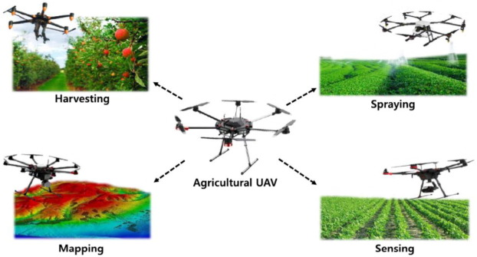

## 

**Smart sensing for agriculture:** sensors are responsible for measuring and monitoring all factors in the smart system; for example, soil health monitoring has special sensors such as nutrients contents, phosphate contents, soil moisture, and compaction and so on. The smart [irrigation system](https://www.sciencedirect.com/topics/earth-and-planetary-sciences/irrigation-system) included many sensors for monitoring water levels, irrigation efficiency, climate sensors, etc.

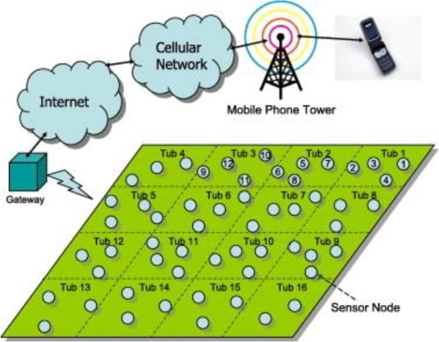

The agricultural **robot** is a robot used in many agricultural practices. IoT has contributed to the development of robots to achieve multiple agricultural activities, where robots can perform many functions instead of humans. In the US and Europe and numerous nations in Asia, they stretched out to the utilization of such current innovation in farming, where robots have further developed agribusiness proficiency, as they diminished working expenses and decreased working time.

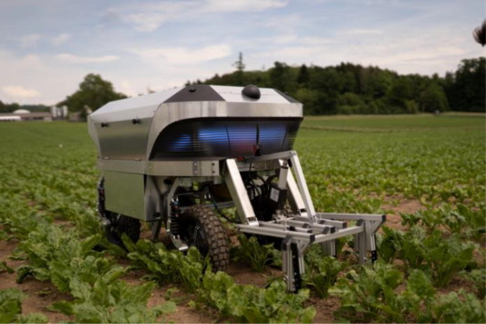

**PROPOSED WORK / SYSTEM**

In our project we have tried to solve or reach every possible method to solve the problem of farmers . our project farmers helper work in three flows

**R programming** This is used to predict the future weather condition to get results. We have used two algorithms: simple moving average and exponential smoothing algorithm . We take data of 20 years and implement this two algorithm in our dataset and after implementing we learn about trends of mean temp, mean pressure, humidity and wind speed and plot graph by which we analyze future pattern and trend which is used by farmers to see what weather can be seen on a particular day or month or season so that he can plan for his crops accordingly.

**Through** R programming we know Future and past weather data but for Present day data such as max,min temp , wind direction , deg,gust,visibility, sea level,ground level,pressure,cloud number. Use node red flow and program it using openweathermap node .

**Tinkercad** As we know farmers face many obstacles in their crop field land such as bird damaging crop, snake , destroy of crop due to high temperature , due to increase in water level, due to bad gaseous substance so to prevent crop from damage we have made circuit which contains different types of sensor to prevent above activity and aware the owner about the situation.

**Proximity sensor** Is used to detect if any animal is entering the field buzzer will start buzzing.

Potentiometer is used to detect water level.

LDR sensor is used to check the temperature if exceed the given value buzzer will start buzzing.

**Gas sensor** is used to detect harmful gas. If gas comes into the environment then it will start buzzing. And there are many small sensors which are used in circuits to prevent all the things which can affect the crop.

**FLOW CHART/ SYSTEM DESIGN OF PROPOSED WORK**

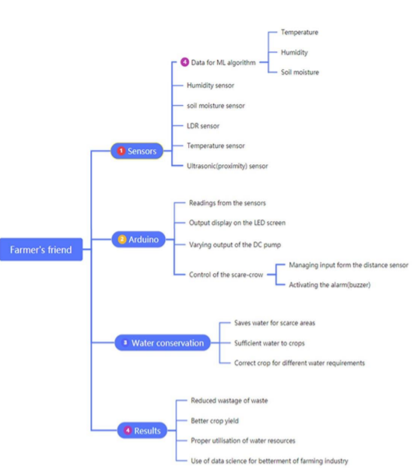

**WORKING MODULES**

* Gas sensor implementation
* Proximity and LDR sensor implementation
* Temperature and soil moisture sensor implementation
* R programming
* Node red
* Tinkercad

**DESCRIPTION OF EACH MODULES WITH APPROPRIATE DIAGRAM AND EXPLANATION**

**Gas sensor implementation:** Gas Sensor that maintains the level of healthy gases for the crops and if there are any harmful gases around the indicator LEDs connected to it notify the farmer about any anomaly and besides that there is a buzzer connected to this circuit that will also notify the farmer.

**Proximity and LDR sensor implementation:** A proximity sensor is a sensor that detects the presence of nearby objects without requiring physical contact. Ultrasonic sensors are regularly utilized as a closeness sensor, setting an edge distance which can decide if an article is an obstruction.A LDR Sensor Module has a (variable) opposition that changes with the light force that falls upon it. This permits them to be utilized in light detecting circuits. It provides analog reading/ value to IOT Devices. It can directly upload reading to iCloud using nutty engineer's IOT Device.

**Temperature and soil moisture sensor implementation:**Temperature sensors measure the amount of heat energy in a source, permitting them to recognize temperature changes and convert these progressions to information. Hardware utilized in assembling regularly requires natural and gadget temperatures to be at explicit levels.

The soil moisture sensor is a basic gadget for estimating the dampness level in soil and comparative materials. The soil moisture sensor is clear to utilize. Assess ideal soil dampness substance for different types of plants. Screen soil moisture content to control irrigation in the greenhouse.

**R programming:** Shows the data analysis in R programming of mean temperature,mean pressure,humidity and wind speed. Two types of algorithms are used in R programming: simple moving average and exponential smoothing algorithm.

**Simple Moving Average Forecasting**: It is an arithmetic moving average calculated by adding the recent values and then dividing that figure by the number of time periods in the calculation of the average.

**Exponential Smoothing Forecasting**: It is a time series forecasting method for univariate data that can be extended to support data with a systematic trend or seasonal component. It can be used to make short-term forecasts

To perform Simple Moving Average and Exponential Smoothing forecasting two packages are required. “TTR” and “forecast”. “TTR” package supports SMA() function that performs Simple Moving Average forecasting and the “forecast” package supports HoltWinters() function that performs the Exponential Smoothing forecasting. Both these packages were imported.

A CSV weather dataset, depicting weather details of every month over a range of years, was read from the computer using the ‘read.csv()’ function and stored in the variable ‘weatherdata’. The data read was viewed by giving the variable name ‘weatherdata’. A data frame containing 4 columns and 120 rows of data was displayed.

The function ‘colnames(weatherdata)’ displays a list of all the column names of the dataset. This is to know what all weather data we have in the dataset. Columns are – ‘meantemp’, ‘humidity’, ‘wind speed’ and ‘mean pressure’.

For column ‘meantemp’

Forecasting using Simple Moving Average:

To perform time series analysis on the ‘meantemp’ column it is stored as a time series object in R. The ‘ts()’ function is used for this purpose. As the dataset depicts seasonal data (weather data for every month over a range of years), the ‘ts()’ function takes the parameters – the ‘mean temp’ column values using ‘weather data$mean temp’, the frequency as 12 depicting the seasonal data is collected monthly and the start value as 2010 which represents the first year the data was collected. The time series object was stored in a variable ‘mtemptimeseries’.

mtemptimeseries <- ts(weather data$mean temp, frequency=12, start=c(2010))

The timeseries object can be viewed by just using the name of the variable, that is, ‘mtemptimeseries’ and the values in the time series can be plotted using the function – ‘plot.ts(mtemptimeseries)’. The ‘plot.ts()’ function is for plotting a time series.

Considering the ‘mtemptimeseries’ as a non-seasonal time series and using the SMA() function (for Simple Moving Average) we can estimate the trend component of the series. SMA() is used to smooth the time series data. To use the SMA() function we need to specify the variable storing the time series and the order of the simple moving average using the parameter ‘n’. Here, ‘n’ is taken as 3. The resulting time series is stored in a variable ‘mtemptsSMA’.

attempts SMP<-SMA(mtemptimeseries,n=3)

The estimated trend value is viewed using the ‘mtemptsSMA’ variable and plotted using the ‘plot.ts(mtemptsSMA)’ function.

A new data-frame is created which stores the combined values of actual time series and estimated time series to view the comparison. The ‘cbind()’ function takes as argument, both the time series and combines them column wise. So, the resulting data frame contains two columns. Values of both these columns were plotted on the same graph to observe the smoothening of the time series using SMA().

plot(mtemptimeseries,col=‘red’)

lines(mtemptsSMA,col=‘blue’)

Now considering the data as seasonal time series, the time series can be decomposed into trend, seasonal and an irregular component. Decomposing means estimating the values of these three components. The decompose() function is used for this purpose. This function takes the time series as the parameter. The decompose() function returns a list object as its result where all the estimates are stored. Each component can be viewed by using ‘$trend’, ‘$seasonal’ after the variable name storing the decomposed values. The whole result object can also be plotted. It will give 4 graphs for 4 components.

mtemptseriescomp<-decompose(mtemptimeseries)

mtemptseriescomp$seasonal

plot(mtemptseriescomp)

**Forecasting using the Exponential Smoothing:**

For Exponential smoothing the ‘HoltWinters()’ function is used. As our data is a seasonal time series, this function only takes the time series as its parameter, no need of giving ‘beta’ and ‘gamma’ values. Smoothing is controlled by the parameters: ‘alpha’, - for estimates of the level, ‘beta’ – slope b of the trend, ‘gamma’ – seasonal component. The parameters ‘alpha’, ‘beta’ and ‘gamma’ all have values between 0 and 1, and values that are close to 0 mean that relatively little weight is placed on the most recent observations when making forecasts of future values. The function returns a list variable, containing the estimated ‘alpha’, ‘beta’ and ‘gamma’ values.

time series forecast<-HoltWinters(mtemptimeseries)

time series forecast

The forecasts made by HoltWinters() are stored in a named element of this list variable called “fitted”.

time series forecast$fitted We can also plot the original time series against the forecasts by using the ‘plot()’ function.

plot(time series forecast)

As a measure of the accuracy of the forecasts, we can calculate the sum of squared errors for the in-sample forecast errors. The sum-of-squared-errors is stored in a named element of the list variable called “SSE”.

time series forecast$SSE

In case we want to use the first value in the time series as the initial value for the level in exponential smoothing, we can specify the value using the ‘l.start’ parameter in the HoltWinters() function.

Holt Winters(temp time series,l.start=15.91304348)

We stored the predictive model for ‘meantemp’ time series in ‘mtempseriesforecast’. We can further forecast for a specific time point by using the ‘h’ parameter in ‘forecast.HoltWinters()’ function. ‘h’ value tells the number of months for which forecasting is to be done in the case of a seasonal time series. We can also plot the forecasted values.

mtempseriesforecast2<-forecast:::forecast.HoltWinters(mtempseriesforecast,h=24)

mtempseriesforecast2

plot(mtempseriesforecast2)

These followed exactly for performing Smooth Moving Average forecasting and Exponential Smoothing forecasting of the other columns – ‘humidity’ ‘wind speed’ and ‘mean pressure’.

**Node red:** Node red is used to check the present day data for wind speed, maximum and minimum temperature, humidity and mean pressure.

**Tinkercad:** We created a digital prototype of our project on TinkerCad.TinkerCad circuit consisting of the relative multitude of sensors and vital parts was planned and this establishes our advanced model of the task.

**COMPLETE PROGRAM :-**

<https://drive.google.com/folderview?id=1PtAtWct4TkaB5W7PK7u6xA1MAnyOs_EE>

**SCREENSHOTS OF OUTPUT:-**

[**https://drive.google.com/folderview?id=1Qcg7hWzkIdrzvBfB4pbbscM85-3lJezu**](https://drive.google.com/folderview?id=1Qcg7hWzkIdrzvBfB4pbbscM85-3lJezu)

**CONCLUSION**

The soil moisture is a critical parameter for developing a smart irrigation system. The soil moisture is affected by a number of environmental variables, e.g., air temperature, air dampness, UV, soil temperature, and so on With headway in innovations, the climate determining exactness has improved fundamentally and the climate estimated information can be utilized for forecast of changes in the dirt dampness. Our undertaking proposes an IoT based brilliant water system design alongside a mixture AI based way to deal with foreseeing the dirt dampness. The proposed calculation utilizes sensors' information of the late past and the climate anticipated information for expectation of soil dampness of forthcoming days. The anticipated worth of the dirt dampness is better as far as their exactness and mistake rate.

Further, the forecast approach is incorporated into an independent framework model. The framework model is financially savvy, as it depends on the open standard innovations. The auto mode makes it a shrewd framework and it tends to be additionally modified for application explicit situations.

The project, Farmer’s friend, has much future scope. If reproduced at a bigger level, it can definitely bring about a significant approach for water conservation.

In Future, an Intelligent IoT based Automated Irrigation system can be extended not just for irrigating the field with water but also for deciding on spraying appropriate chemicals for proper growth of crops. The same work can be extended by looking into water level in the tank before irrigating the field. Lastly the data security and integrity of agricultural data can be secured while transmitting for analysis towards prediction and sending the control signal for actuation.

**FUTURE WORK**

For future an mobile application can be build by which we can operate this more easily can also have a camera sensor which can we used to see field 24*7 If the owner is outside for a few weeks, the mobile can be used or can have a function button by which we can turn on/off the motor to adjust the temperature.Increase and decrease the sound of buzzer .

Artificial intelligence can be also used to make sensors work more smoothly and add new features so that as the time passes technology can be upgraded with the same flow.

To predict more parameters, different algorithms can be also implemented. This will help us to get more parameters' predicted value and also gives us more clarity of the upcoming weather condition so that farmers can be prepared for any kind of weather change .

A density sensor can be included which can check soil if fertilizer is needed or not if it gives a signal then farmers can check and spread the required amount of fertilizer.

**REFERENCES**

[1] Darshna, S., Sangavi, T., Mohan, S., Soundharya, A., and Desikan, S., 2015. Darshna, S., Sangavi, T., Mohan, S., Soundharya, A., and Desikan, S. Irrigation system with intelligence 10(3), IOSR Journal of Electronics and Communication Engineering (IOSR-JECE), pp. 32-36.

S. Rawal, Rawal, Rawal, Rawal, Rawal, Rawal, Rawal, Rawal, Raw Smart irrigation system based on the Internet of Things. 159(8), pp. 7-11 in International Journal of Computer Applications.

Apoorva Tyagi, S. Harishankar, R.S. Kumar, K.P. Sudharsan, U. Vignesh, and T. Viveknath, 2014. Smart watering system fueled by the sun. 4(4), pp.341-346 in Advances in Electronic and Electrical Engineering.

[4] H. Benyezza, M. Bouhedda, K. Djellout, and A. Saidi, November 2018. ThingSpeak and Arduino are used to create a smart irrigation system. The International Conference on Applied Smart Systems (ICASS) was held in 2018. (pp. 1-4). IEEE.

[5] D. K. Fisher and H. A. Kebede, "A low-cost microcontroller-based system to monitor crop temperature and water status," Comput. Electron. Agricult., vol. 74, no. 1, Oct. 2010, pp.168–173.

[6] Karan Kansara, Vishal Zaveri, Shreyans Shah, Sandip Delwadkar, and Kaushal Jani, "Sensor-based Automated Irrigation System with IOT: A Technical Overview."

[7] Sumeet S. Bedekar, Monoj A. Mechkul, and Sonali R. Deshpande are Sumeet S. Bedekar, Monoj A. Mechkul, and Sonali R. Deshpande are Sumeet S. Bedekar, Monoj A. IJSRD - International Journal for Scientific Research and Development | Vol. 3, Issue 04, 2015 | ISSN (online): 2321-0613. "IoT based Automated Irrigation System," IJSRD - International Journal for Scientific Research and Development | Vol. 3, Issue 04, 2015 | ISSN (online): 2321-0613.

[8] G.Parameswaran and K.Sivaprasath, "Arduino Based Smart Drip Irrigation System Using IOT," published in the International Journal of Engineering Science and Computing (IJESC) in May 2016.

[9] S.Reshma and B.A.Sarath Manohar Babu, "Internet of Things Based Automatic Irrigation System Using Wireless Sensor Networks," International Journal and Magazine of Engineering, Technology, Management and Research, vol-03, Issue-09, September 2016.

[10] R. Nandhini, S. Poovizhi, Priyanka Jose, R. Ranjitha, and S. Anila. Nandhini, R., S. Poovizhi, Priyanka Jose, R. Ranjitha, and S. Anila. "Arduino-based smart irrigation system with Internet of Things." IICT, Coimbatore, 3rd National Conference on Intelligent Information and Computing Technologies, 2017.